EXPLORE THE WORLD WITH SHEAFE’S FLAT BLUEBIRD
Due: Friday, March 23, 2012
STUDENT NAME: _________________________________________________ ROOM _______________
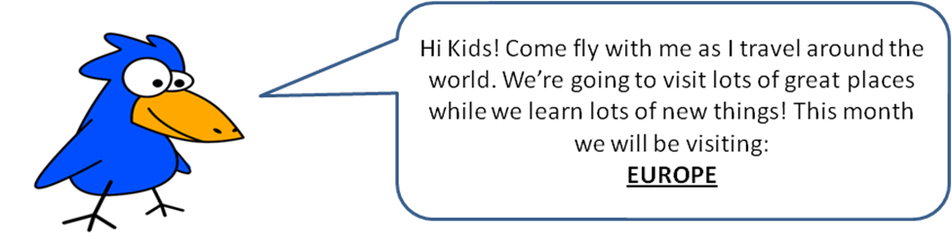
There are a lot of countries to see in Europe. This week, I’m traveling through northern Europe. I’m going to start in Iceland. On the map below, Iceland is the island that is in the upper left corner. (Remember an island is surrounded by water on all sides.) Iceland is the world’s 18th largest island and Europe’s second largest island following Great Britain. From Iceland, I’m flying directly east, across the North Atlantic Ocean, to Norway. Norway has a long coastline and is famous for its fjords. A fjord is a long, narrow inlet with steep sides or cliffs created in a valley by glaciers. From Norway, I’m flying right next door (to the east) to Sweden. Sweden is one of the largest countries in Europe. Like Norway, Sweden also has a very long coastline. It also has many forests and lakes. From Sweden, I’ll keep flying east to the biggest country in Europe: Russia! Actually, Russia is both in Europe and Asia (that’s the continent I visited last month!). Russia is the largest country in the world! It’s going to take me all week to fly around Russia. Come back next week to see what other European countries I’ll be visiting. ☺
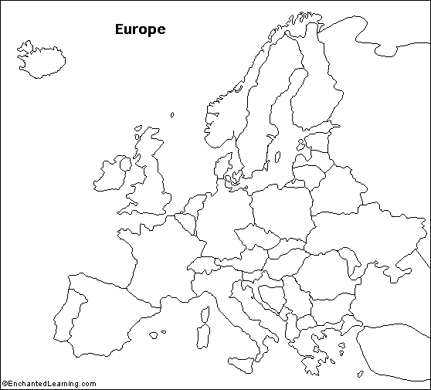

Using the information above and the compass rose, color and label the following countries:
Iceland – gray
Norway – yellow
Sweden – green
Russia – purple

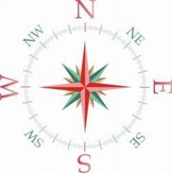

The flag of Russia has three colors. White is the top color, followed by blue and red is the bottom color.
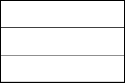

With adult permission, do some research and see if you can find out the answers to the following questions about Russia. Good luck!
1. Where would you find these buildings in Russia?

2. What is the capital city of Russia?
3. This famous Russian wrote the music to “The Nutcracker” ballet. What is his name?
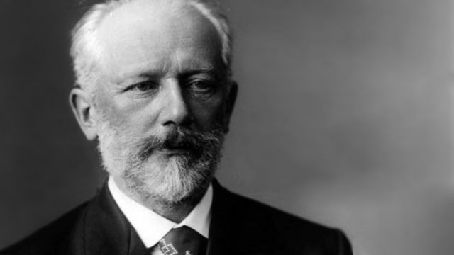
4. This famous Russian leader was the President of the USSR from 1988 – 1991. He won the Nobel Peace Prize and helped to end the Cold War.
